**DETECTION OF DIABETIC RETINOPATHY USING ALEXNET AND LENET CNN Models**

**A PROJECT REPORT**

***Submitted By***

**NEYA BABU T (180701152)**

**NIKGHAMANTH S S (180701153)**

***In partial fulfilment for the award of the degree***

***Of***

# BACHELOR OF ENGINEERING

**IN**

**COMPUTER SCIENCE AND ENGINEERING**



**RAJALAKSHMI ENGINEERING COLLEGE, CHENNAI-602105**

# ANNA UNIVERSITY: CHENNAI 600 025

**APRIL 2021**

# ANNA UNIVERISTY: CHENNAI 600 025

## BONAFIDE CERTIFICATE

Certified that this project report **“DETECTION OF DIABETIC RETINOPATHY USING ALEXNET AND LENET CNN Models**” is the bonafide work of “**NEYA BABU T. (180701152) & NIKGHAMANTH S.S. (180701153)** ”whocarried out the project under my supervision.



**SIGNATURE** **SIGNATURE**

|  |  |
| --- | --- |
| Dr. REVATHY Mrs. V. JANANEE |  |
| **HEAD OF THE DEPARTMENT** **SUPERVISOR** |  |
| Professor Assistant Professor |  |
| Department of Computer Science Department of Computer Science  And Engineering And Engineering |  |
| Rajalakshmi Engineering College Rajalakshmi Engineering College |  |
| Chennai – 602 105 Chennai – 602 105 |  |
|  |  |

Submitted to Project and Viva Examination held on

**INTERNAL EXAMINER** **EXTERNAL EXAMINER**

i

## ACKNOWLEDGEMENT

I extend my gratitude to my Chairman **Mr. S. MEGANATHAN,** Chairperson **Dr. THANGAM MEGANATHAN** and Vice Chairman **Mr. ABHAY SHANKAR MEGANATHAN** for providing me with all the necessary resources and other facilities towards completion of this project. I am extremely grateful to thank my principal **Mr. S.N. MURUGESAN** for giving me a valuable support and encouragement throughout the duration of this course.

I wish to thank **Dr. REVATHY**, Ph.D, Head of the Department, Department of Computer Science and Engineering, Rajalakshmi Engineering College, for extending all facilities to me to work on this project. I take this opportunity to thank our coordinator **Mrs. PRITHI** Professor, Department of Computer Science and Engineering, Rajalakshmi Engineering College for his kind direction.

I would like to express my sincere appreciation and gratitude to my guide **Mrs. V. JANANEE**, Assistant Professor, Department of Computer Scienceand Engineering, Rajalakshmi Engineering College for his guidance, constant encouragement, and support. His meticulous attention and creative thinking have been a source of inspiration for me throughout this project. I also extend my sincere thanks to **all faculty members** and supporting staffs for their direct and indirect involvement in successful completion of the project. All endeavors over a long period can be successful only with the advice and support of many well-wishers. I take this opportunity to express my gratitude and appreciation to all of them. Above all, I express my heartfelt thanks to my parents and family members who have dedicated their life to my well-being.

ii

## ABSTRACT

Diabetic Retinopathy is a condition that is caused by excessive glycemia.

It can often be tough to tell the variation among DR and fundus photographs. To avoid difficulties, it is crucial to acknowledge the difference before concluding the disease and grafting the treatment plan. We can detect many Diabetic Eye Disease illnesses using Cnns. In addition to this, Cnns also detects the colors and patterns of sores and matches them to relevant conditions during medical diagnosis, which is similar to human decision-making. The Django web framework showcases the best output that is derived after comparing 3 models of Cnn. To determine the most efficient and accurate categorization of Diagnosed images, researchers use many related images as input into this convolutional semantic networks. The output derived shows whether the given input image is affected with DR or not.

iii

## TABLE OF CONTENTS

**CHAPTER****TITLE****PAGE**

**NO** **NO**

**ABSTRACT** **iii**

**1** **LIST OF FIGURES** **vi**

**LIST OF TABLES vii**

**INTRODUCTION** **1**

1.1 MOTIVATION 1

1.2 STOCKS 2

1.3 UNDERSTANDING STOCKS 2

1.4 HOW STOCK MARKET WORKS 3

1.5 FUNCTIONS OF STOCK MARKET 4

1.6 REGULATING STOCK MARKET 7

1.7 PURPOSE OF STOCK MARKET 7

1.8 RECURRENT NEURAL NETWORKS 8

1.9 LONG SHORT-TERM MEMORY 9

1.10 ADABOOST ALGORITHM 9

1.10.1 ALGORITHM 10

**2 LITERATURE SURVEY**  **11**

**3 SYSTEM ARCHITECTURE** **17**

* 1. EXISTING SYSTEM 17

3.2 PROPOSED SYSTEM 17

3.2.1 ADVANTAGES 18

3.3 WORKING STEPS 18

3.4 PROPOSED SYSTEM ARCHITECTURE 19

3.5 SYSTEM REQUIREMENTS 19

3.5.1 SOFTWARE REQUIREMENTS 19

3.5.2 HARDWARE REQUIREMENTS 20

3.6 DESIGN OF THE ENTIRE SYSTEM 21

3.6.1 SEQUENCE DIAGRAM 21

3.6.2 USECASE DIAGRAM 21

3.6.3 COLLABORATION DIAGRAM 22

**4 IMPLEMENTATION 24**

4.1 MODULE 24

4.1.1 DATA PREPROCESSING MODULE 24

4.1.1.1 FEATURING EXTRACTION 25

4.1.2 LSTM TRAINING MODULE 25

4.1.3 ADABOOST ENSEMBLE MODULE 26

**5 RESULTS AND DISCUSSION 27**

**6 CONCLUSION AND FUTURE WORK 28**

**7 REFERNCES 29**

**8 APPENDIX 31**

**9 PAPER PUBLICATION 39**

v

## LIST OF FIGURES

### FIGURETITLE PAGE

**1.1**  **WORKING OF RNN NETWORK** **8**

**1.2** **LSTM NETWORK**  **9**

**3.1 SYSTEM ARCHITECTURE 19**

**3.2 WORKING OF THE MODEL IN SEQUENCE DIAGRAM 21**

**3.3 STOCK PREDICTION BY USER 22**

**3.4 COLLABORATION DIAGRAM 23**

**5.1 GRAPH RESULT 25**

vi

**LIST OF TABLES**

**TABLE NO TITLE PAGE**

**4.1 DETAILS IN STOCK DATA 24**

vii

**CHAPTER 1**

## INTRODUCTION

To wage the therapy, it is important to identify the disease. In simplified words, complications result in problem and thus finding the actually present disease in the given image from the datasets and separating other diseases from the DR diseases is essential. Since DR diseases are often confused with fundus photographs, these are the major complications found while finding the datasets for analyzing this disease. So, it is important to separate them before training . This task is proficiently done with Convolutional Neural Network.

* 1. **MOTIVATION**

Diabetic Retinopathy is a deadly disease with no cure or prevention. Early detection and medications are the only way to stall it from complicating or becoming deadly. When a person is affected by DR, they slowly lose their eye sight leading to permanent blindness. This has lead us to take up this project and search for already existing methods used for early detection. We found certain flaws in those methods and thus decided to improve them with our proposed system for the betterment in treating people affected with this illness.

* 1. **DIABETIC RETINOPATHY**

It is a diabetes complication that affects eyes. It's caused by damage to the blood vessels of the light-sensitive tissue at the back of the eye (retina).

* 1. **UNDERSTANDING DR**

Diabetic retinopathy is caused by changes in the blood vessels of the retina, the light-sensitive layer of tissue at the back of the inner eye. In some people with diabetic retinopathy, the blood vessels in the retina may swell and leak fluid. In others, abnormal new blood vessels grow on the surface of the retina. There is no cure for diabetic retinopathy. But treatment works very well to prevent, delay, or reduce vision loss. The sooner the condition is found, the easier it is to treat. One of such treatment is laser treatment, which is used predominantly while tackling this disease. There are some early symptoms of DR such as spots or dark strings floating in your vision (floaters), Blurred vision, Fluctuating vision, Dark or empty areas in your vision & Vision loss. There are also 4 types of DR namely, Mild Nonproliferative Retinopathy, Moderate Nonproliferative Retinopathy, Severe Nonproliferative Retinopathy & Proliferative Diabetic Retinopathy (PDR)

* 1. **DETECTION OF DR USING IMAGE CLASSICIATION**

Machines can be taught to mimic the same way human brains interpret and analyze images and its features. Artificial Intelligence with image Processing has many application and lay foundation to modern technologies such as face recognition in mobile phones and other applications to ensure high level security, detecting and recognizing objects and patterns in images and videos, and so on. Today, image processing is widely used in medical visualization, biometrics, self-driving vehicles, gaming, surveillance, law enforcement, and many other domains. Some of the image processing application and where it is used widely are, Visualization which represents processed data in a human understandable way, giving visual form of objects that are easy to explain and helps to make key decision, Image sharpening and restoration which improve the quality of images that are processed, image retrieval which helps to search with image. Object detection which is used to detect objects in an image, [Pattern recognition](https://en.wikipedia.org/wiki/Pattern_recognition" \t "_blank) classifies objects, their positions and understand the hidden pattern in an image.

There are millions of diseases that already exist or are originated in this world. Thanks to the advanced technologies and image processing, these diseases can be very accurately detected and treated upon the affected. The computed tomography (CT) scans, ultrasounds, magnetic resonance imaging (MRI)—to help the health care practitioner identify the cause of disease. A **Convolutional Neural Network (ConvNet/CNN)**is a Deep Learning algorithm which can take in an image, assign parameters (learnable weights and biases) to objects in the image and be able to differentiate one from the other. The pre-processing required in a ConvNet is much lower as compared to other classification algorithms. While in primitive methods filters are hand-engineered, with enough training, ConvNets have the ability to learn these filters/characteristics of an image automatically. The architecture of a ConvNet is analogous to that of the connectivity pattern of Neurons in the Human Brain and was inspired by the organization of the Visual Cortex. Individual neurons respond to stimuli only in a restricted region of the visual field known as the Receptive Field. A collection of such fields overlaps to cover the entire visual area.

The objective is to develop a design for Diabetic eye disease or DR, by classification algorithms for possibly arriving the cause and the kind of supreme precision by contrasting the original style.

Thus, the CNN is used to analyze the given retinal image and first helps in differentiating DR images from fundus photographs. Then, the deep learning module helps to understand whether the disease is present in the given input image from the datasets or not.

**1.5 CONVOLUTIONAL NEURAL NETWORK ARCHITECTURE**

A CNN has three layers: a convolutional layer, a pooling layer, and a fully connected layer.

**1.5.1 Convolution Layer**

The convolution layer is the core building block of the CNN. It carries the main portion of the network’s computational load. This layer performs a dot product between two matrices, where one matrix is the set of learnable parameters also known as a kernel, and the other matrix is the restricted portion of the receptive field. The kernel is spatially smaller than an image but is more in-depth in feature extraction, for example if the image is composed of three (RGB) channels, the kernel height and width will be spatially small, but the depth extends up to all three channels.

During the forward propagation, the kernel slides across the height and width of the image-producing the image representation of that receptive region. This produces a 2D representation of the image known as an activation map that gives the response of the kernel at each spatial position of the image. The sliding size of the kernel is called a stride.

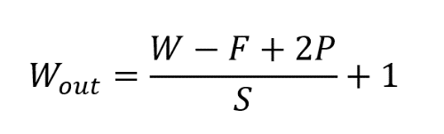 If we have an input of size W x W x D and D out number of kernels with a spatial size of F with stride S and amount of padding P, then the size of output volume can be determined by the following formula:

**Figure 1.1 Formula -Output Volume Size**

This results an output volume of size W out x W out x D out.

**Motivation behind Convolution**

Convolution leverages three important purpose that motivated computer vision researchers are sparse interaction, parameter sharing, and equivariant representation.

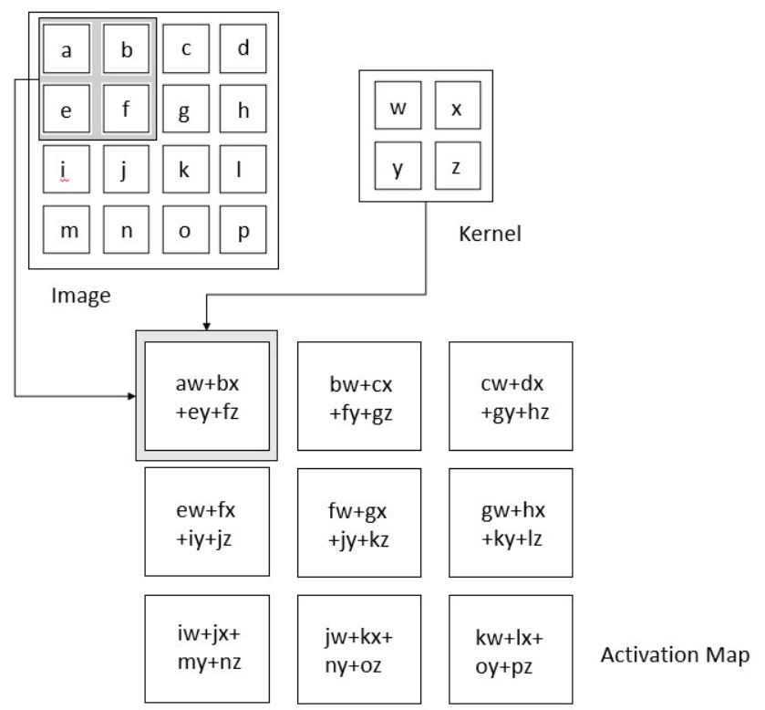

**Figure 1.2 Activation Map**

Neural network layers use matrix multiplication by a matrix of parameters describing the interaction between the input and output. This means that every output unit interacts with every input unit. Convolution neural networks have sparse interaction which is achieved by making kernel smaller than the input e.g., an image can have millions of pixels, but while processing it using kernel, we can detect features that is of fewer pixels which also implies that we need to store fewer parameters that reduces the memory requirement of the model and also improves the efficiency of the model.

Computing one feature at a spatial point (x1, y1) is useful then other spatial point say (x2, y2) is equivalently useful too. It implies that for a single 2D slice, for one activation map creation, neurons are constrained to use the same set of weights. In traditional neural network, each element of the weight matrix is used only once, while convolution network has shared parameters that includes both trainable and non-trainable parameters for outputs.

Because of parameter sharing, the layers of convolution neural network will have a property of equivariance to translation, which implies that change in the input results in the output.

**Pooling Layer**

The pooling layer replaces the output of the network at certain locations by deriving a summary statistic of the nearby outputs. This helps in reducing the spatial size of the representation, and also decreases the computation cost and weights. The pooling operation is applied on every slice of the representation individually.

There are several pooling functions such as the average of the rectangular neighbourhood, L2 norm of the rectangular neighbourhood, and a weighted average based on the distance from the central pixel. However, the most popular process is max pooling, which reports the maximum output from the neighbourhood.

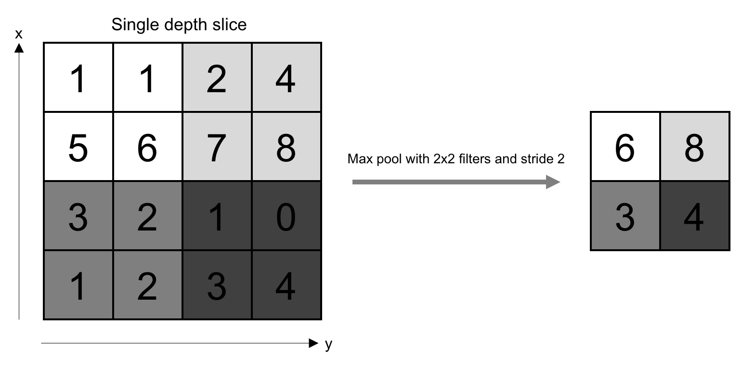

**Figure 1.3 Pooling Layer Activation Map**

If we have an activation map of size W x W x D, a pooling kernel of spatial size F, and stride S, then the size of output volume can be determined by the following formula:

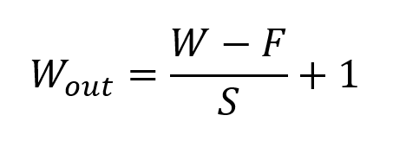

**Figure 1.4 Formula -Output Size for padding Layer**

**Formula for Padding Layer**

This will yield an output volume of size W out x W out x D. In all cases, pooling provides some translation invariance which means that an object would be recognizable regardless of where it appears on the frame.

**Fully Connected Layer**

Neurons in this layer have full connectivity with all neurons in the preceding and succeeding layer as seen in regular FCNN. This is why it can be computed as usual by a matrix multiplication followed by a bias effect. The FC layer helps to map the representation between the input and the output.

**Activation Functions**

Since convolution is a linear operation and images are far from linear, non-linearity layers are often placed directly after the convolutional layer to introduce non-linearity to the activation map. There are several types of non-linear operations, the popular ones being:

**Sigmoid**

The sigmoid non-linearity has the mathematical form σ(κ) = 1/(1+e¯κ). It takes a real-valued number and “squashes” it into a range between 0 and 1. However, a very undesirable property of sigmoid is that when the activation is at either tail, the gradient becomes almost zero. If the local gradient becomes very small, then in backpropagation it will effectively “kill” the gradient. Also, if the data coming into the neuron is always positive, then the output of sigmoid will be either all positives or all negatives, resulting in a zig-zag dynamic of gradient updates for weight.

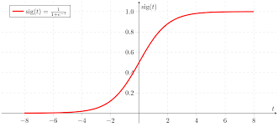

**Figure 1.5 Activation Function – Sigmoid**

**Tanh**

Tanh squashes a real-valued number to the range [-1, 1]. Like sigmoid, the activation saturates, but — unlike the sigmoid neurons — its output is zero centred.

**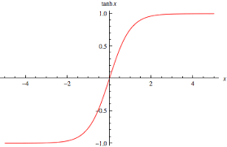Figure 1.6 Activation Function – TanH**

**ReLU**

The Rectified Linear Unit (ReLU) has become very popular in the last few years. It computes the function ƒ(κ)=max (0, κ). In other words, the activation is simply threshold at zero. In comparison to sigmoid and tanh, ReLU is more reliable and accelerates the convergence by six times.

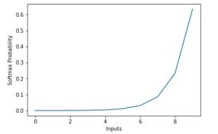

**Figure 1.7 Activation Function – ReLU**

Unfortunately, a con is that ReLU can be fragile during training. A large gradient flowing through it can update it in such a way that the neuron will never get further updated. However, we can work with this by setting a proper learning rate.

**1.6 MANUALNET ARCHITECTURE**

ManualNet architecture is our proposed architecture created by having the already existing AlexNet and LeNet architectures as the base. The architecture has 3 layers and thus has less errors and takes lesser time to complete its training and testing of datasets. This architecture yields an output of 98.44% max\_accuracy consistently.

*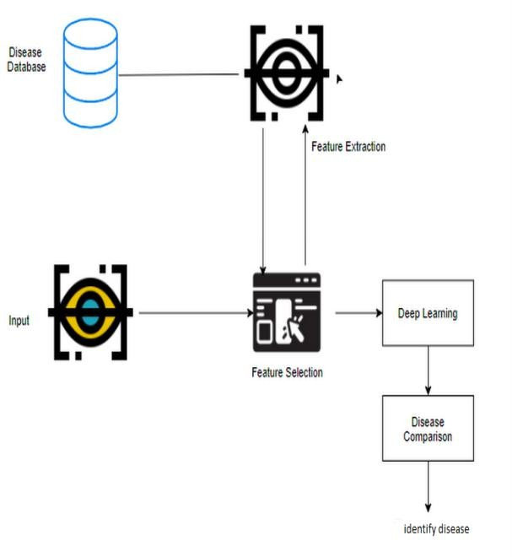*

**1.7 ALEXNET ARCHITECTURE**

The Alexnet has eight layers with learnable parameters. The model consists of five layers with a combination of max pooling followed by 3 fully connected layers and they use Relu activation in each of these layers except the output layer. This architecture also yields error-free results without complications or time consumption compared to other bigger architectures like RESNET-50 as it has lesser layers with an output of 95% max\_accuracy.

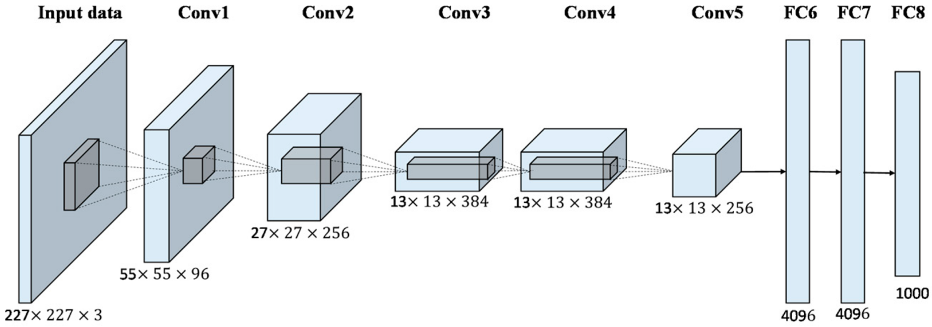

**1.8 LENET ARCHITECTURE**

The Lenet has 5 layers with learnable parameters and hence named Lenet-5. It has three sets of convolution layers with a combination of average pooling. After the convolution and average pooling layers, we have two fully connected layers. It is the most successful and consistent architecture of all the existing CNN architectures and yields an output of 100% max\_accuracy and with an average accuracy of more than 98% consistently.

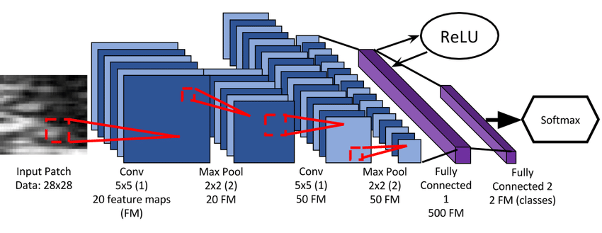

**CHAPTER 2**

## LITERATURE SURVEY

A literature survey or a literature review in a project report is that section which shows the various analyses and research made in the field of your interest and the results already published, taking into account the various parameters of the project and the extent of the project.

The following papers are studied in the following survey:

1. A Deep Learning Ensemble Approach for Diabetic Retinopathy Detection. (2020)

Sehrish Qummar, Fiaz Gul Khan, Sajid Shah, Ahmad Khan[, Shahaboddin Shamshirband](https://ieeexplore.ieee.org/author/37586305200)[,   
Zia Ur Rehman](https://ieeexplore.ieee.org/author/38551528900), Iftikhar Ahmed Khan & Waqas Jadoon are the authors of this paper.

Advantages : Very high accuracy

Disadvantages : The method proposed, although finds PDR(final stage) cannot find the earlier symptoms or stages of DR.

1. Improved and robust deep learning agent for preliminary detection of Diabetic Retinopathy using public datasets. (2020)

[Gaurav Saxena](https://www.sciencedirect.com/science/article/pii/S2666521220300223" \l "!), [Dhirendra Kumar Verma](https://www.sciencedirect.com/science/article/pii/S2666521220300223" \l "!), [Amit Paraye](https://www.sciencedirect.com/science/article/pii/S2666521220300223" \l "!), [Alpana Rajan](https://www.sciencedirect.com/science/article/pii/S2666521220300223" \l "!) & [Anil Rawat](https://www.sciencedirect.com/science/article/pii/S2666521220300223" \l "!) proposed this paper.

Advantages : Fast coverage of data sets having image with similar feature size

Disadvantages : Processing time is large because of the huge dataset that is used here.

1. Detection of Diabetic Retinopathy Using Bichannel Convolutional Neural Network.

Shu-I Pao, Hong-Zin Lin, Ke-Hung Chien, Ming-Cheng Tai, Jiann-Torng Chen &

Gen-Min Lin proposed this paper.

Advantages : Improves the detection performance by deep learning

Disadvantages : Given dataset is relatively smaller.

1. Diabetic Retinopathy Classification Using ResNet50 and VGG-16 Pretrained Networks.

(2019)

Mustapha AATILA, Mohamed LACHGAR, Hamid HRIMECH & Ali KARTIT proposed this paper.

Advantages : High accuracy

Disadvantages : The architectures require large training datasets and powerful machines to work as the time taken is very high. Even though the output yielded by these architectures are excellent, smaller architectures like LeNet and AlexNet are more successful as they are easily trainable and executable due to their small architecture.

5. Advances in the treatment of diabetic retinopathy. (2020)

[Rishi P Singh](https://pubmed.ncbi.nlm.nih.gov/?term=Singh+RP&cauthor_id=31669065) [1](https://pubmed.ncbi.nlm.nih.gov/31669065/" \l "affiliation-1" \o "Center for Ophthalmic Bioinformatics, Cole Eye Institute, Cleveland Clinic, 9500 Euclid Avenue, Cleveland, OH 44195, USA. Electronic address: drrishisingh@gmail.com.), [Michael J Elman](https://pubmed.ncbi.nlm.nih.gov/?term=Elman+MJ&cauthor_id=31669065) [2](https://pubmed.ncbi.nlm.nih.gov/31669065/" \l "affiliation-2" \o "Elman Retina Group, 9114 Philadelphia Road, Baltimore, MD 21237, USA. Electronic address: elman@elmanretina.com.), [Simran K Singh](https://pubmed.ncbi.nlm.nih.gov/?term=Singh+SK&cauthor_id=31669065) [3](https://pubmed.ncbi.nlm.nih.gov/31669065/" \l "affiliation-3" \o "Louis Stokes Cleveland Veterans Affairs Medical Center, 10701 East Boulevard, Cleveland, OH 44106, USA. Electronic address: Simran.Singh@va.gov.), [Anne E Fung](https://pubmed.ncbi.nlm.nih.gov/?term=Fung+AE&cauthor_id=31669065) [4](https://pubmed.ncbi.nlm.nih.gov/31669065/" \l "affiliation-4" \o "Genentech, Inc., 1 DNA Way, South San Francisco, CA 94080, USA. Electronic address: fung.anne@gene.com.), [Ivaylo Stoilov](https://pubmed.ncbi.nlm.nih.gov/?term=Stoilov+I&cauthor_id=31669065) proposed this paper.

Advantages : Well classified and high accuracy

Disadvantages : Not using simpler architectures like Alexnet and Lenet for image classification.

6. Classification of Diabetic Retinopathy Images by Using Deep Learning Models.(2019)

[Suvajit Dutta](https://www.researchgate.net/profile/Suvajit-Dutta), [Bonthala C S Manideep](https://www.researchgate.net/profile/Bonthala-Manideep), [Muzamil Basha](https://www.researchgate.net/profile/Muzamil-Basha) & [Ronnie D. Caytiles](https://www.researchgate.net/scientific-contributions/Ronnie-D-Caytiles-2026731168) proposed this paper.

Advantages : pre-processing of the images is done before training stage.

Disadvantages : Image size is so high (2000x2000) which might not be idle for all the images from the available datasets and might also affect the clarity of the images which in-turn affects its accuracy.

7. Detection of Diabetic Retinopathy and Maculopathy in Eye Fundus Images Using Deep Learning and Image Augmentation. (2019)

[Sarni Suhaila Rahim](https://www.researchgate.net/scientific-contributions/Sarni-Suhaila-Rahim-2076154205), [Vasile Palade](https://www.researchgate.net/profile/Vasile-Palade), [Ibrahim Almakky](https://www.researchgate.net/profile/Ibrahim-Almakky) & [Andreas Holzinger](https://www.researchgate.net/profile/Andreas-Holzinger-4) proposed this paper.

Advantages : Using data augmentation and image classification technique together to yield high accuracy.

Disadvantages : No actual implementation, thus no actual fact to backup the consistency of accuracy that is yielded.

1. Issues in Training a Convolutional Neural Network Model for Image Classification.

(2019)

[Soumya Joshi](https://www.researchgate.net/profile/Soumya-Joshi), [Dhirendra Kumar Verma](https://www.researchgate.net/scientific-contributions/Dhirendra-Kumar-Verma-2158995044), [Gaurav Saxena](https://www.researchgate.net/profile/Gaurav-Saxena-8) & [Amit Payaye](https://www.researchgate.net/scientific-contributions/Amit-Payaye-2159006537) propsed this paper.

Advantages : uses CNN to effectively classify two huge datasets.

Disadvantages : Not related to DR.

1. Deep Learning Methods for Underwater Target Feature Extraction and Recognition. (2020)

Gang Hu, Kejun Wang, Yuan Peng, Mengran Qiu, Jianfei Shi & Liangliang Liu proposed this paper.

Advantages : very high accuracy and best method for classifying images.

Disadvantages : Not related to disease identification.

10. Diabetic kidney disease and diabetic retinopathy: the ominous duo. (2020)

[Vijay Viswanathan](https://www.researchgate.net/profile/Vijay-Viswanathan-2) proposed this paper.

Advantages : Provides good accuracy in finding the diseases and clearly explains the relationship between the kidney and retinopathy diseases.

Disadvantages : Does not provide an actual solution for classifying diabetic retinopathy disease from other eye diseases.

**CHAPTER 3**

## SYSTEM ARCHITECTURE

System architecture is the conceptual model that defines the structure, behavior and more views of a system. An architecture description is a formal description and representation of a system, organized in a way that supports reasoning about the structures and behaviors of the system. A system architecture can comprise system components, the expand systems developed, that will work together to implement the overall system.

**3.1 EXISTING SYSTEM**

The drawbacks are:

1. Lacks accuracy
2. Performance is less

**3.2 PROPOSED SYSTEM**

Features of the CNN

CNN extract these photos from information sets and arrange them to proportions before codification, as mentioned. Two-step process of extraction and organization along with  background subtraction portion is handled by Con2D and max pooling. This both uncovers and eliminates the functionalities which are visible. Every filter is performed through an associated layer. All of them are segregated based on the tasks found.

This then offers a theoretical study of Photographs of various types of DED, collected as samples. The form and texture-oriented attributes are the item's crucial elements. Feature learning with Dnns and rapid state recognition have shown tremendous success in the diagnosis of numerous Neuropathy situations.

System Style

Firstly, we must enter a photograph into the system. Following that, the item selection occurs. Afterwards, the algorithm eliminates the traits and assesses which ailments are existent in the sickness database. Ultimately, it returns to the feature option component to indulge in more in-depth study. Further comparison of the ailments obtained shows the disease that best matches the parameters. That's how a Dcnn operates.

**3.3 WORKING STEPS**

1. Image to be processed are selected from the disease database.

2. The images are sent for feature extraction.

3. An input image is given for feature selection.

4. Cross referring to the extraction process, the image is sent for processing further.

5. Deep learning module is executed.

6. Disease comparison is done to confirm whether the input image has the disease or not.

7. Output is shown.

**3.4 PROPOSED SYSTEM ARCHITECTURE**

**

Fig 3.1 System Architecture

### 3.5 SYSTEM REQUIREMENTS

Requirements analysis, also called requirements engineering, is the process of determining user expectations for a new or modified software or project. These features, called requirements, must be quantifiable, relevant and detailed. In software engineering, such requirements are often called functional specifications.

#### 3.5.1 SOFTWARE REQUIREMENTS

The software requirements are the specification of the system. It should include both a definition and a specification of requirements. It is a set of what the system should do rather than how it should do it. The software requirements provide a basis for creating the software requirements specification. It is useful in estimating cost, planning team activities, performing tasks and tracking the teams and tracking the team’s progress throughout the development activity.

* Operating system : Windows 10
* Languages used : Python
* Software Package : Anaconda 3

#### 3.5.2 HARDWARE REQUIREMENTS

The hardware requirements may serve as the basis for a contract for the implementation of the system and should therefore be a complete and consistent specification of the whole system. They are used by software engineers as the starting point for the system design. It shows what the systems do and not how it should be implemented.

|  |  |  |
| --- | --- | --- |
| • | Hard disk | : 1 TB (minimum) |
| • | Platform | : IA-32(Windows Package Only) |
| • | Ram | : 8 GB RAM |
| • | Processor | : Pentium IV/III |
| • | Processor speed | : Minimum 1.99 GHZ |

**CHAPTER 4**

## IMPLEMENTATION

Implementation is the phase where vision and plans become reality. This is the logical conclusion after evaluating, deciding, planning and finding the financial resources of a project. Technical implementation is one part of executing a project.

### 4.1 MODULES

* Module 1 - ManualNet architecture.
* Module 2 - AlexNet architecture.
* Module 3 - LeNet architecture.

#### MANUALNET ARCHITECTURE

#### This module is designed manually to train and test the diabetic retinopathy’s retinal datasets that are taken from the retinal database ‘STARE’.

#### The module is called the ManualNet and it gives the accuracy of 98.44%.

#### ManualNet is an attempt to create our own image classification architecture with AlexNet and LeNet as its base.

#### This module is also compared with the same existing image classification architectures that are coded in next modules.

#### The system architecture in the above slide is the flow diagram for this module.

#### ALEXNET ARCHITECTURE

This module comprises the AlexNet architecture.

AlexNet architecture consists of 8 layers.

The module is trained and tested with the same dataset used in module 1 and the output of its accuracy is compared with ManualNet in module 1 and LeNet in module 3.

The accuracy of this module is 89.70% which is less than ManualNet and LeNet.

The architecture of AlexNet is shown in the next slide.

#### 4.1.3 LENET ARCHITECTURE

This module comprises the LeNet architecture.

LeNet architecture consists of 5 layers.

The module is trained and tested with the same dataset as used in module 1 and the output of its accuracy is compared with ManualNet in module 1 and AlexNet in module 2.

The accuracy of this module is 96.80% which is the highest accuracy when compared with ManualNet and AlexNet.

The architecture of LeNet is shown in the next slide.

## CHAPTER 5

**RESULTS AND DISCUSSION**

In the proposed system, we train all the three architectures with the same given datasets and compare them in terms of their respective accuracies and losses. The architecture with maximum average accuracy with least loss is considered the best architecture to yield the output of whether diabetic retinopathy disease is present in the given input image or not.

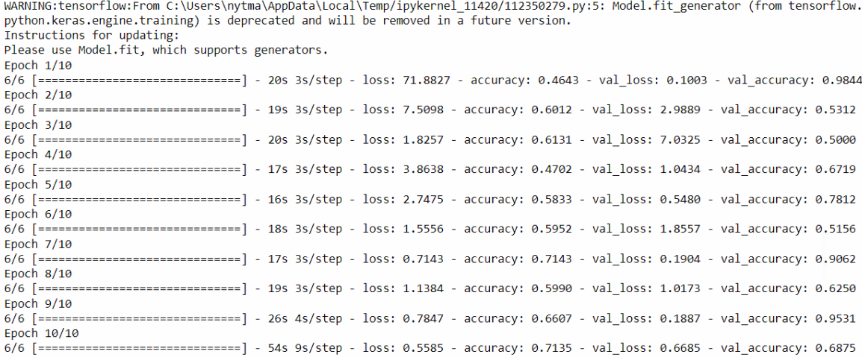

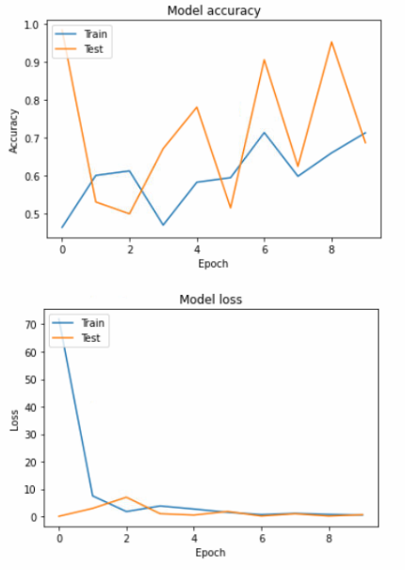

Fig 5.1 Output and Graph Results of ManualNet

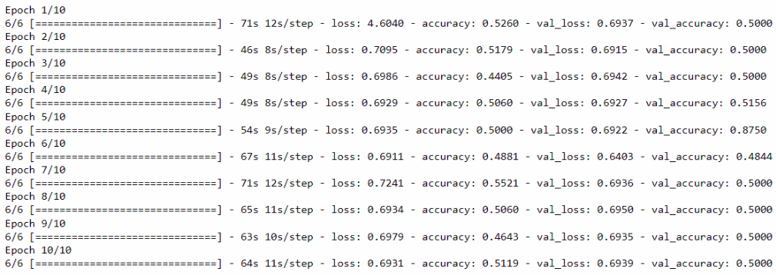

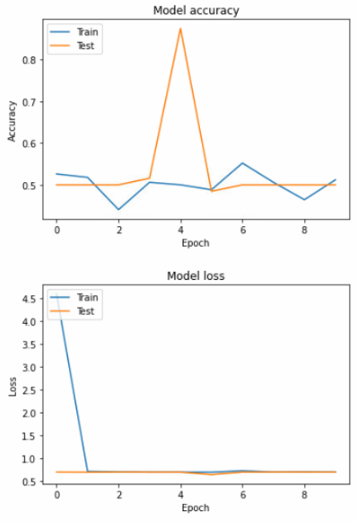

Fig 5.2 Output and Graph Results of AlexNet

**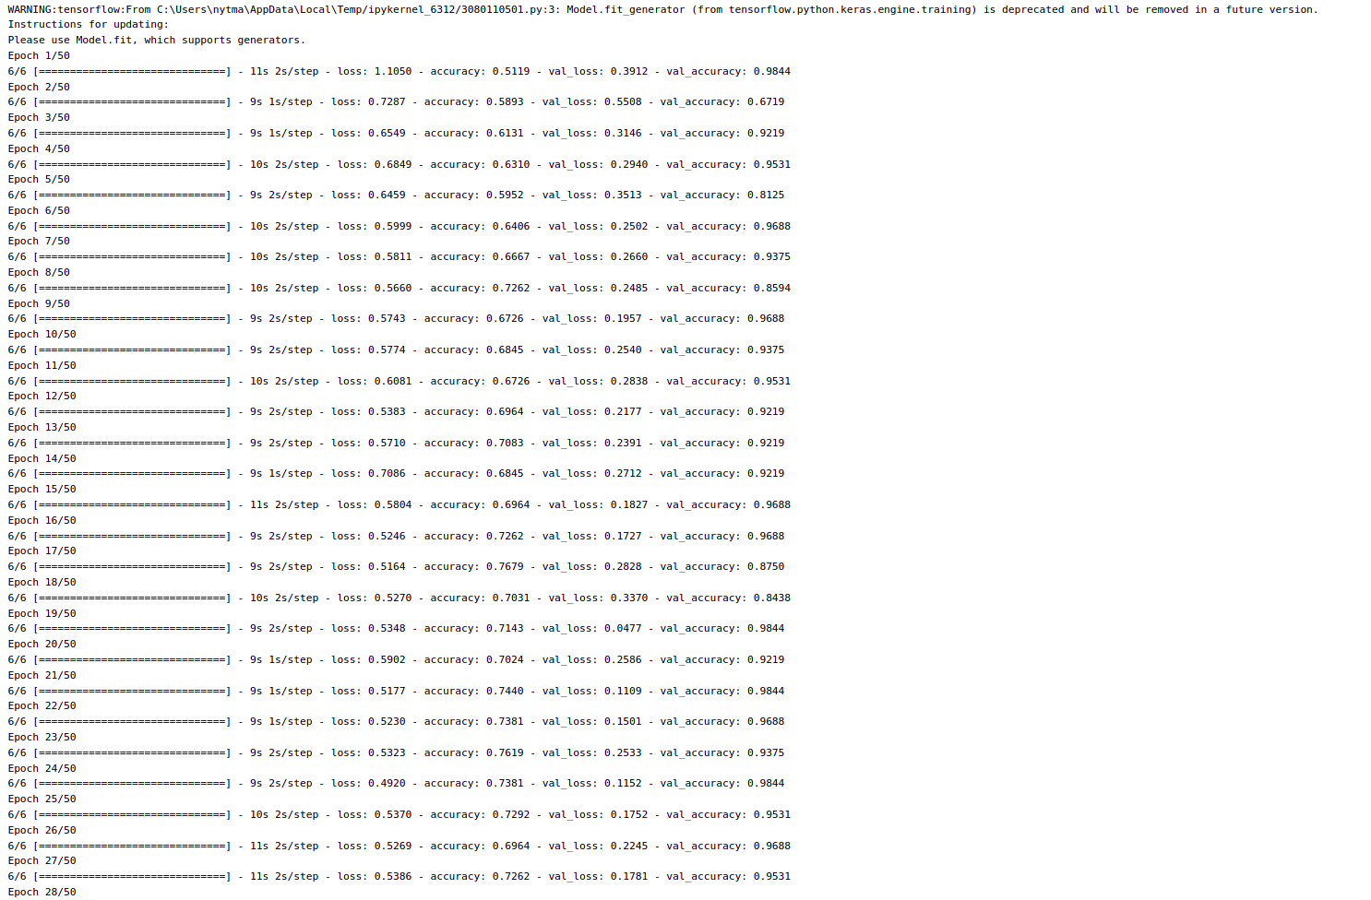**

**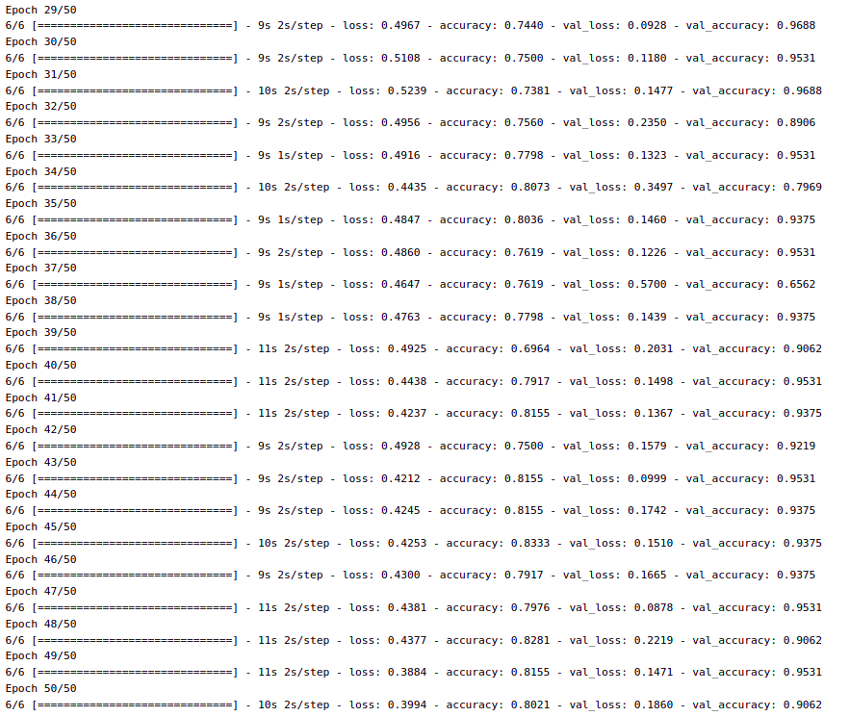**

Fig 5.3 Output Results of LeNet

## CHAPTER 6

### CONCLUSION AND FUTURE WORK

Our work focused on how the images from given data set (trained dataset) and past data sets are used to predict the pattern of diabetic retinopathy diseases using CNN model. This brings some of the following insights about diabetic retinopathy disease prediction. The major benefit of the CNN classification framework is the ability to classify images automatically.

In this study, we have discussed the overview of methodologies for detecting the abnormalities in diabetic retinopathy images which includes collection of retinopathy image data set, preprocessing techniques, feature extraction techniques and classification schemes.

In the future works, we will satisfy the medical department requirements, that are necessary to automate the detecting of diabetic retinopathy disease for eligibility process (real time) and also deploying it in cloud.

#### REFERENCES

#### 

1. [Sehrish Qummar](https://ieeexplore.ieee.org/author/37087058778), [Fiaz Gul Khan](https://ieeexplore.ieee.org/author/37087061987), [Sajid Shah](https://ieeexplore.ieee.org/author/37087057929), [Ahmad Khan](https://ieeexplore.ieee.org/author/38313549000), [Shahaboddin Shamshirband](https://ieeexplore.ieee.org/author/37586305200), [Zia Ur Rehman](https://ieeexplore.ieee.org/author/38551528900) & [Iftikhar Ahmed Khan](https://ieeexplore.ieee.org/author/37087060290), “A Deep Learning Ensemble Approach for Diabetic Retinopathy Detection”

*IEEE* (2019)

1. GauravSaxena, Dhirendra KumarVerma, Amit Paraye, AlpanaRajan & AnilRawat, “Improved and robust deep learning agent for preliminary detection of Diabetic Retinopathy using public datasets” (Intelligence-Based- Medicine, Volumes 3-4, 2020)
2. Shu-I Pao, Hong-Zin Lin, Ke-Hung Chien, Ming-Cheng Tai, Jiann-Torng Chen & Gen-Min Lin, “Detection of Diabetic Retinopathy Using Bichannel Convolutional Neural Network” (Enrico Peiretti, 2020)
3. Mustapha Aatil, Mohamed Lachgar, Hamid Hrimech & Ali Kartit, “Diabetic Retinopathy Classification Using ResNet50 and VGG-16 Pretrained Networks” (IJCEDS, volume 1, 2021)
4. [Rishi P.Singh](https://www.sciencedirect.com/science/article/abs/pii/S1056872719303733), [Michael J.Elman](https://www.sciencedirect.com/author/7003376888/michael-j-elman), [Simran K.Singh](https://www.sciencedirect.com/science/article/abs/pii/S1056872719303733), [Anne E.Fung](https://www.sciencedirect.com/science/article/abs/pii/S1056872719303733) & [Ivaylo Stoilov](https://www.sciencedirect.com/science/article/abs/pii/S1056872719303733), “Advances in the treatment of diabetic retinopathy” *PubMed (*2019)
5. Suvajit Dutta, Bonthala CS Manideep, Syed Muzamil Basha, Ronnie D. Caytiles & N. Ch. S. N. Iyengar, “Classification of Diabetic Retinopathy Images by Using Deep Learning Models” *International Journal of Grid and Distributed Computing (*2019)
6. Sarni Suhaila Rahim, Vasile Palade, Ibrahim Almakky & Andreas Holzinger, “Detection of Diabetic Retinopathy and Maculopathy in Eye Fundus Images Using Deep Learning and Image Augmentation” *International cross-domain conference*, *UK* (2019)
7. Soumya Joshi, Dhirendra Kumar Verma, Gaurav Saxena & Amit Paraye, “Issues in Training a Convolutional Neural Network Model for Image Classification” *International Conference on Advances in Computing and Data Science* (2019).
8. Gang Hu, Kejun Wang, Yuan Peng, Mengran Qiu, Jianfei Shi & Liangliang Liu, “Deep Learning Methods for Underwater Target Feature Extraction and Recognition” (Rasit Koker, 2019)
9. [Yann LeCun](https://www.nature.com/articles/nature14539), [Yoshua Bengio](https://www.nature.com/articles/nature14539) & [Geoffrey Hinton](https://www.nature.com/articles/nature14539), “Deep Learning Concepts”, (Nature, 2020)
10. [Vijay Viswanathan](https://link.springer.com/article/10.1007/s13410-020-00867-8), “Diabetic kidney disease and diabetic retinopathy: the ominous duo” *International Journal of Diabetics in Developing Countries* (2020)
11. K Sathyavani, H Kothandan, M Jayaraman & V Viswanathan, “Direct costs associated with chronic kidney disease among type 2 diabetic patients in India” (indiajnephrol.org, 2019)
12. Amol Prataprao Bhatkar & G.U. Kharat, “Detection of Diabetic Retinopathy in Retinal Images using MLP classifier” *IEEE* (2019)
13. Yashal Shakti Kanungo, Bhargav Srinivasan & Savitha Choudhary, “Detecting Diabetic Retinopathy using Deep Learning” *IEEE* (2020)
14. Xianlong Zeng, Haiquan Chen, Yuan Luo & Wenbin Ye, “Automated Diabetic Retinopathy Detection Based on Binocular Siamese-like Convolutional Neural Network” *IEEE* (volume 7, 2019)
15. C Jayakumari, Vidhya Lavanya & E P Sumesh, “Automated Diabetic Retinopathy Detection and classification using ImageNet Convolutional Neural Network using Fundus Images” *IEEE* (2020)
16. Supriya Mishra, Seema Hanchate & Zia Saquib, “Diabetic Retinopathy Detection using Deep Learning” *IEEE* (2020)
17. [Sara Hosseinzadeh Kassani](https://ieeexplore.ieee.org/author/37087134157), [Peyman Hosseinzadeh Kassani](https://ieeexplore.ieee.org/author/37085647376), [Michal J. Wesolowski](https://ieeexplore.ieee.org/author/37086047294), [Kevin A. Schneider](https://ieeexplore.ieee.org/author/37398664500) & [Ralph Deters](https://ieeexplore.ieee.org/author/37281897400), “Breast Cancer Diagnosis with Transfer Learning and Global Pooling” *IEEE* (2019)
18. Seema Garg & Richard M. Davis, “Diabetic Retinopathy Screening Update” (American Diabetics Association, 2020)
19. Ramachandran Rajalakshmi, Vijayaraghavan Prathiba, Subramanian Arulmalar & Manoharan Usha, “Review of retinal cameras for global coverage of diabetic retinopathy screening” (Nature-eye, 2020)

**APPENDIX**

**CODE:**

**MANUALNET ARCHITECTURE**

import os

import numpy as np # linear algebra

import matplotlib.pyplot as plt

# Dl framwork - tensorflow, keras a backend

import tensorflow as tf

import tensorflow.keras.backend as K

from tensorflow.keras.models import Model, Sequential

from tensorflow.keras.layers import Input, Dense, Flatten, Dropout, BatchNormalization

from tensorflow.keras.layers import Conv2D, SeparableConv2D, MaxPool2D, LeakyReLU, Activation

from tensorflow.keras.optimizers import Adam

from tensorflow.keras.preprocessing.image import ImageDataGenerator

from tensorflow.keras.callbacks import ModelCheckpoint, ReduceLROnPlateau, EarlyStopping

from IPython.display import display

from os import listdir

from os.path import isfile, join

from PIL import Image

import glob

from tensorflow.keras.preprocessing.image import ImageDataGenerator

from tensorflow.keras.layers import Convolution2D

from tensorflow.keras.layers import MaxPooling2D

from tensorflow.keras.layers import Flatten

from tensorflow.keras.layers import Dense

import warnings

warnings.filterwarnings('ignore')

dir\_name\_train\_No\_DR = 'dataset/Train/No\_DR'

dir\_name\_train\_Severe = 'dataset/Train/Severe'

def plot\_images(item\_dir, n=6):

all\_item\_dir = os.listdir(item\_dir)

item\_files = [os.path.join(item\_dir, file) for file in all\_item\_dir][:n]

plt.figure(figsize=(80, 40))

for idx, img\_path in enumerate(item\_files):

plt.subplot(3, n, idx+1)

img = plt.imread(img\_path)

plt.imshow(img, cmap='gray')

plt.axis('off')

plt.tight\_layout()

def Images\_details\_Print\_data(data, path):

print(" ====== Images in: ", path)

for k, v in data.items():

print("%s:\t%s" % (k, v))

def Images\_details(path):

files = [f for f in glob.glob(path + "\*\*/\*.\*", recursive=True)]

data = {}

data['images\_count'] = len(files)

data['min\_width'] = 10\*\*100 # No image will be bigger than that

data['max\_width'] = 0

data['min\_height'] = 10\*\*100 # No image will be bigger than that

data['max\_height'] = 0

for f in files:

im = Image.open(f)

width, height = im.size

data['min\_width'] = min(width, data['min\_width'])

data['max\_width'] = max(width, data['max\_height'])

data['min\_height'] = min(height, data['min\_height'])

data['max\_height'] = max(height, data['max\_height'])

Images\_details\_Print\_data(data, path)

print("")

print("Trainned data for No\_DR:")

print("")

Images\_details(dir\_name\_train\_No\_DR)

print("")

plot\_images(dir\_name\_train\_No\_DR, 10)

print("")

print("Trainned data for Severe:")

print("")

Images\_details(dir\_name\_train\_Severe)

print("")

plot\_images(dir\_name\_train\_Severe, 10)

Classifier=Sequential()

Classifier.add(Convolution2D(32,(3,3),input\_shape=(512,512,3),activation='relu'))

Classifier.add(MaxPooling2D(pool\_size=(2,2)))

Classifier.add(Flatten())

Classifier.add(Dense(38, activation='relu'))

Classifier.add(Dense(2, activation='softmax'))

Classifier.compile(optimizer='rmsprop',loss='categorical\_crossentropy',metrics=['accuracy'])

train\_datagen=ImageDataGenerator(rescale=1./255,shear\_range=0.2,zoom\_range=0.2,horizontal\_flip=True)

test\_datagen=ImageDataGenerator(rescale=1./255)

training\_set=train\_datagen.flow\_from\_directory('dataset/Train',target\_size=(512,512),batch\_size=32,class\_mode='categorical')

test\_set=test\_datagen.flow\_from\_directory('dataset/Test',target\_size=(512,512),batch\_size=32,class\_mode='categorical')

img\_dims = 150

epochs = 10

batch\_size = 32

#### Fitting the model

history = Classifier.fit\_generator(

training\_set, steps\_per\_epoch=training\_set.samples // batch\_size,

epochs=epochs,

validation\_data=test\_set,validation\_steps=test\_set.samples // batch\_size)

def graph():

#Plot training & validation accuracy values

plt.plot(history.history['accuracy'])

plt.plot(history.history['val\_accuracy'])

plt.title('Model accuracy')

plt.ylabel('Accuracy')

plt.xlabel('Epoch')

plt.legend(['Train', 'Test'], loc='upper left')

plt.show()

# Plot training & validation loss values

plt.plot(history.history['loss'])

plt.plot(history.history['val\_loss'])

plt.title('Model loss')

plt.ylabel('Loss')

plt.xlabel('Epoch')

plt.legend(['Train', 'Test'], loc='upper left')

plt.show()

**SCREENSHOT: (from Django Platform were we deployed our model)**

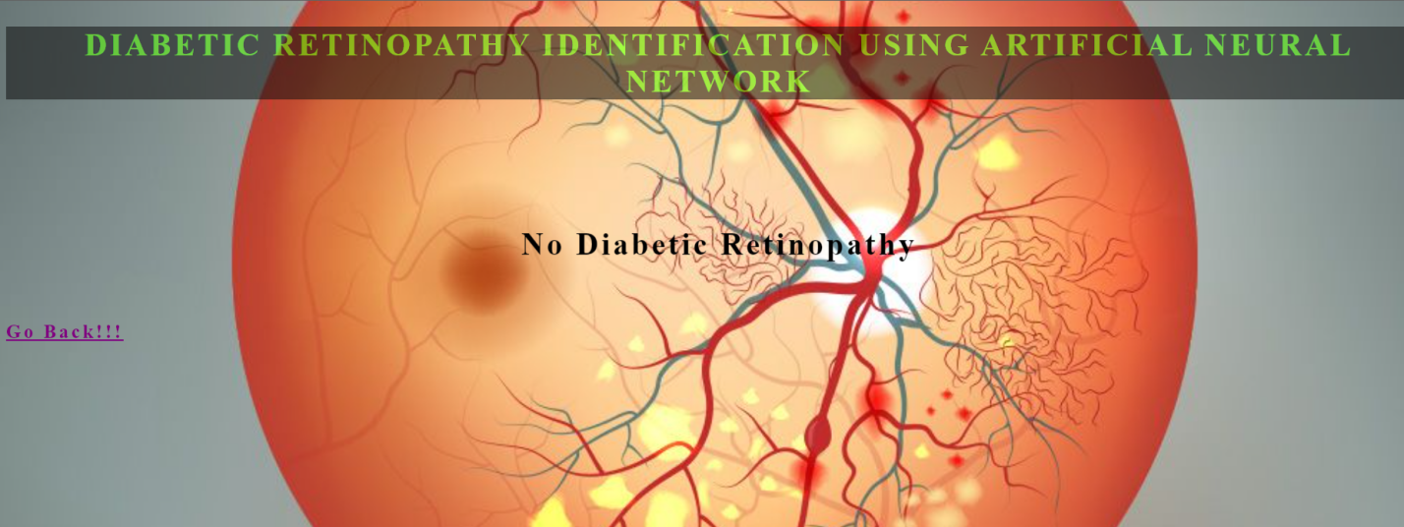

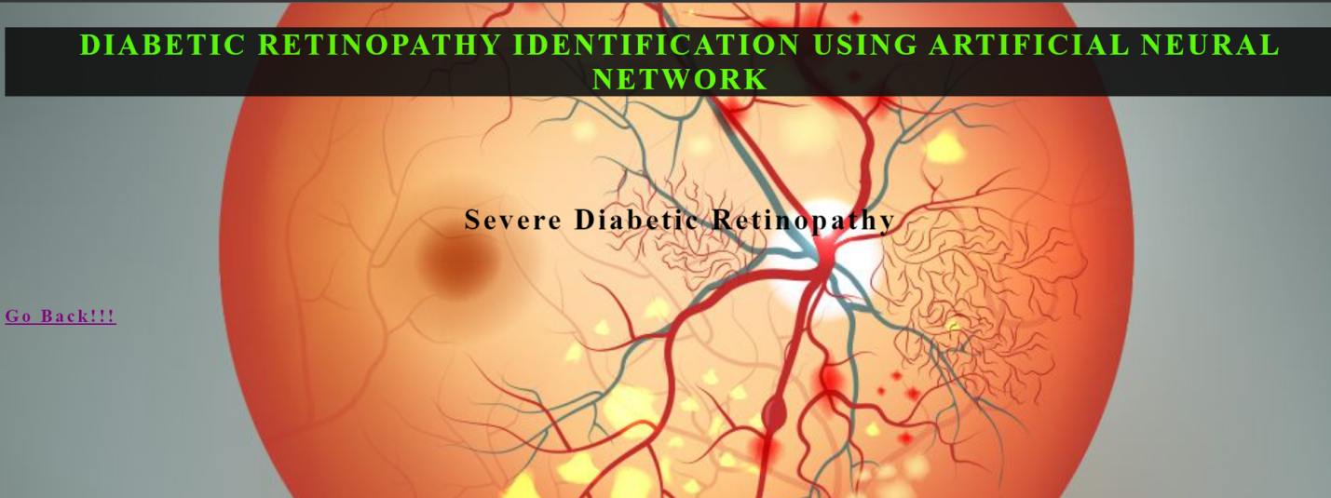

Detection Of Diabetic Retinopathy Using Alexnet and Lenet CNN Models

Jananee V(Assistant Professor)1, Shanthalakshmi M(Assistant Professor)2, Sherine Glory J(Assistant Professor)3, Vaidhya G K ( Research scholar)4, Nikghamanth Seshadri Narayanan(student)5 and Neya Babu Thayil(student)6.

*1Rajalakshmi Engineering College, Rajalakshmi nagar, Thandalam, Chennai-602105, Tamil Nadu.*

*a)[jananee.v@rajalakshmi.edu.in](mailto:jananee.v@rajalakshmi.edu.in" \t "https://mail.google.com/mail/u/2/?ogbl" \l "inbox/_blank)*

*b)[shanthalakshmi.m@rajalakshmi.edu.in](mailto:shanthalakshmi.m@rajalakshmi.edu.in" \t "https://mail.google.com/mail/u/2/?ogbl" \l "inbox/_blank)*

*c)[sherinegloryj@gmail.com](mailto:sherinegloryj@gmail.com" \t "https://mail.google.com/mail/u/2/?ogbl" \l "inbox/_blank)*

*d)[vaidhyagk@gmail.com](mailto:vaidhyagk@gmail.com" \t "https://mail.google.com/mail/u/2/?ogbl" \l "inbox/_blank)*

e)*[nikghamanth.ss.2018.cse@rajalakshmi.edu.in](mailto:a)nikghamanth.ss.2018.cse@rajalakshmi.edu.in)[f)](mailto:b)neyababu.t.2018.cse@rajalakshmi.edu.in)[neyababu.t.2018.cse@rajalakshmi.edu.in](mailto:b)neyababu.t.2018.cse@rajalakshmi.edu.in)*

Abstract-- Diabetic Retinopathy is a condition that is caused by excessive glycemia. It can often be tough to tell the variation among both DR and fundus photographs. To avoid difficulties, it is crucial to acknowledge. We can detect many Diabetic Eye Disease illnesse using Cnns. It also detects the colors and patterns of sores and matches them to relevant conditions during medical diagnosis, which is similar to human decision-making. The Django web framework showcases the output. To determine the most efficient and accurate categorization of Diagnosed images, researchers use many related images as input into convolutional semantic networks.

INTRODUCTION

TO WAGE THE THERAPY, IT IS IMPORTANT TO IDENTIFY THE ILLNESS. IN SIMPLIFIED WORDS, COMPLICATION RESULTS IN PROBLEMS. IT LIKEWISE APPLIES TO DIABETIC RETINOPATHY DISEASE. COMPLICATED DIABETIC PERSON RETINOPATHY PHOTOS WITH FUNDUS PICTURES IS An OPPORTUNITY. SO IT'S IMPORTANT TO SEPARATE DIABETIC RETINOPATHY IMAGES FROM FUNDUS PICTURES. WE CAN EFFICIENTLY FULL THIS CRUCIAL TASK BY APPLYING A CONVOLUTIONAL NEURAL NETWORK

A CONVOLUTIONAL SEMANTIC NETWORK CAN TAKE IMAGES AS WELL AS SET APART ONE FROM THE OTHER. THE CNN CANISTER THEN BE USED TO FIND LOTS OF DIABETIC RETINOPATHY ILLNESSES. THE REALITY THAT ITS CONTAINER CAPTURES THE COLORS AND STRUCTURES OF LESIONS CERTAIN TO RESPECTIVE DISEASES DURING MEDICAL DIAGNOSIS IS AN FRINGE BENEFIT. IT STANDS FOR THE CAPABILITY TO MAKE DECISIONS IN HUMAN BEINGS.

A CNN IS AN A1 WHICH MIMICS THE HUMAN KN0WLEDGE. BUT HUMAN INTELLECT ALS0 HAS ITS LIMITATI0NS. THUS, WE CAN C0NCLUDE THAT THE EXPERT SYSTEM IS REFINED AND UPGRADED BRAINPOWER. IT IS CONVINCING TO C0UNT ON THE AI-- A CSN.

THE OBJECTIVE IS TO DEVEL0P A DESIGN FOR DIABETIC EYE DISEASE (DED) PICTURE ANALYSIS BY CLASSIFICATI0N ALGORITHMS FOR P0SSIBLY ARRIVING THE CAUSE AND THE KIND OF SUPREME PRECISI0N BY CONTRASTING THE 0RIGINAL STYLE.

Associated Works

0phthalmoscope

An 0phthalmoscope can obtain, store and analyze images of the occulations. Based on analog pictures, retinal photo handling takes place as well as concerned with the 0bservation of vessels in subcapsular images with flu0rescein [1]. This effulgent improves clarity of repository in the pic. They assist physicians to identify as well as determine. Yet, flu0rescein angi0graphy is an intrusive, thus a taxing procedure.

Technique Specific Attention Network

Technique/Modality-specific attention network (MSAN) makes use of fornix and also 0CT photos all at once to achieve 0phthalmology. The sound in them may disturb the R01 extraction. So, Gaussian filter with bit dimensions are applied for deblurring, as well as presented in-depth understanding methods for flavimactulas picture categorization established upon DED neurilemma discovery. Nevertheless, AlexNet CNN and LeNet models are not implemented for yielding efficient results.

Subcapsular Pics

Supplies shades or clear images of the retina. They are mostly automated, have several benefits in contrast to its precursor. Computerized retinal images offer structured, well-organized and retrievable outputs that are accessible as well as complaisant for picture amplification[2]. Nonetheless, occasionally distorted images may occur.

*PROPOSED STRUCTURE*

*Features of the CSN*

*CSN extract these photos from information sets and arrange them to proportions before codification, as mentioned. Two-step process of extraction and organization along with  background subtraction portion is handled by Con2D and max pooling. This both uncovers and eliminates the functionalities which are visible. Every filter is performed through an associated layer. All of them are segregated based on the tasks found.*

*This then offers a theoretical study of Photographs of various types of DED, collected as samples. The form and texture-oriented attributes are the item's crucial elements. Feature learning with Dnns and rapid state recognition have shown tremendous success in the diagnosis of numerous Neuropathy situations.*

*System Style*

*As shown in "Fig 1." Firstly, we must enter a photograph into the system. Following that, the item selection occurs. Afterwards, the algorithm eliminates the traits and assesses which ailments are existent in the sickness database. Ultimately, it returns to the feature option component to indulge in more in-depth study. Further comparison of the ailments obtained shows the disease that best matches the parameters. That's how a Dcnn operates.*

**

*(A)*

*Development environment*

*In terms of hardware, it requires a Pentium IV/III processor. It needs a minimum 80 GB hard disk and a minimum of 2 GB RAM.*

*In terms of software, it needs Windows/Linux Operating system as well as Anaconda with Jupyter Notebook simulation tool.*

*This twofold requirement is needed to develop the environment for Dcnn.*

Figures



FIGURE 1. ManualNet image processing



FIGURE 2. AlexNet image processing



(a)



(b)

FIGURE 3. LeNet Image processing

*Color Figures*



FIGURE 4. ManualNet Graphical Output



FIGURE 5. AlexNet Graphical Output

*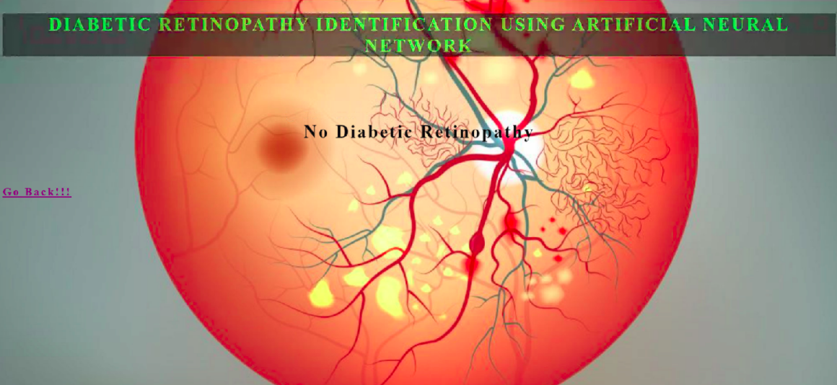*

*(a)*

*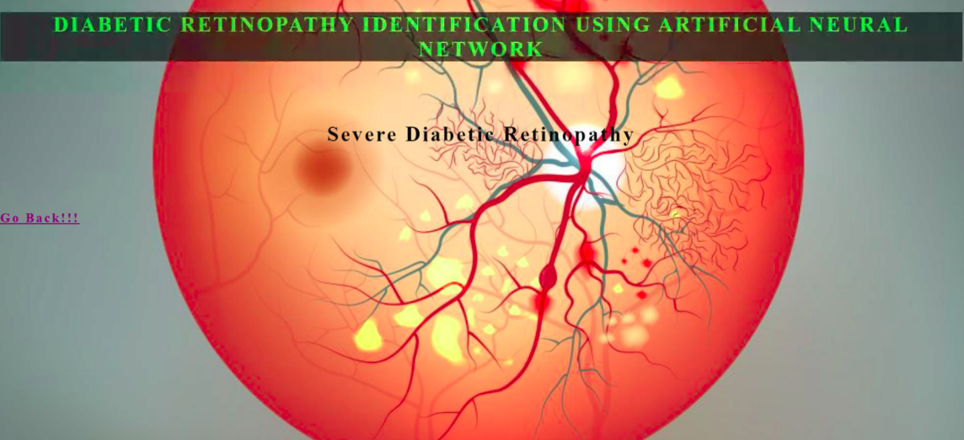*

*(b)*

*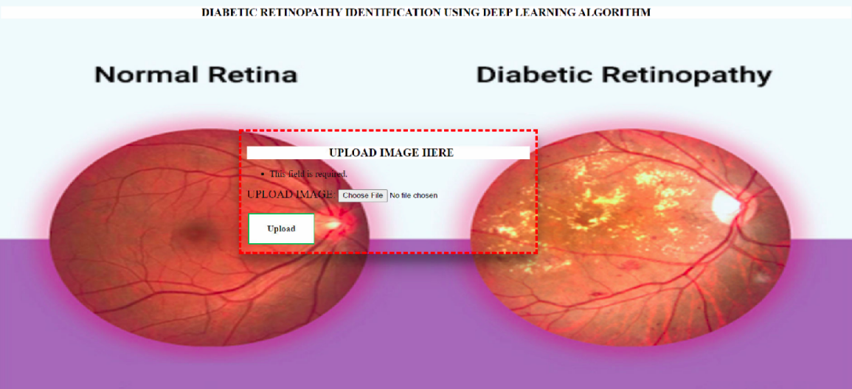*

*(c)*

FIGURE 6. pycharm Output Screenshots

CONCLUSION

THE PROPOSED NETWORK IS CUSTOMIZED TO FORETELL THE TREND OF DR DISEASES BY USING IMAGES FROM ACQUIRED DATA (TRA1NED DATASET) AND ALSO PRIOR DATA SETS. SEVERAL OF THE DR STATE ASSUMPTIONS AND INTERPRETATIONS ARE PROVIDED THROUGH THIS. A MAJOR BENEFIT OF THE AFF0REMENTIONED METH0D IS THE ABILITY TO 1NSTANTLY DISTINGU1SH 1MAGES.  
  
WE C0VERED AN 0VERALL V1EW OF METH0DOLOGIES REGARDING THE ABILITY TO DETECT ISSUES IN DR PH0TOS, INCLUDING PR0LIFERAT1VE DR DATA SET C0LLECT1ON, DATA TRANSF0RMATION STRATEG1ES, COMP0NENT SEGMENTATION TECHN1QUES, AND CATEG0RISATION PROPOSALS IN THIS PAPER.  
  
WE W1LL PLEASE THE MED1CAL DEPARTMENT REQU1REMENTS F0R THE QUALIF1CATION PR0CEDURE BY AUT0MATING THE DISC0VERY OF DIABETIC RETIN0PATHY D1SEASE IN THE FUTURE WORKS (REAL-T1ME).  
WE CAN ALSO USE IT ON THE NET.

ACKN0WLEDGMENTS

WE W0ULD LIKE TO CONVEY OUR HEARTFELT GRAT1TUDE TO OUR ADVISOR AND TEACHER MRS. JANANEE AND H0D MAM TOGETHER WITH OUR TASK C00RDINATORS WH0 SUSTA1NED 0UR SUGGESTION AND PERSPECT1VE THR0UGHOUT THE TASK, SUGGEST1NG ENHANCEMENTS WHEREVER NECESSARY.

REFERENCES

1. [Sehrish Qummar](https://ieeexplore.ieee.org/author/37087058778), [Fiaz Gul Khan](https://ieeexplore.ieee.org/author/37087061987), [Sajid Shah](https://ieeexplore.ieee.org/author/37087057929), [Ahmad Khan](https://ieeexplore.ieee.org/author/38313549000), [Shahaboddin Shamshirband](https://ieeexplore.ieee.org/author/37586305200), [Zia Ur Rehman](https://ieeexplore.ieee.org/author/38551528900) & [Iftikhar Ahmed Khan](https://ieeexplore.ieee.org/author/37087060290), “A Deep Learning Ensemble Approach for Diabetic Retinopathy Detection”

*IEEE* (2019)

1. GauravSaxena, Dhirendra KumarVerma, Amit Paraye, AlpanaRajan & AnilRawat, “Improved and robust deep learning agent for preliminary detection of Diabetic Retinopathy using public datasets” (Intelligence-Based- Medicine, Volumes 3-4, 2020)
2. Shu-I Pao, Hong-Zin Lin, Ke-Hung Chien, Ming-Cheng Tai, Jiann-Torng Chen & Gen-Min Lin, “Detection of Diabetic Retinopathy Using Bichannel Convolutional Neural Network” (Enrico Peiretti, 2020)
3. Mustapha Aatil, Mohamed Lachgar, Hamid Hrimech & Ali Kartit, “Diabetic Retinopathy Classification Using ResNet50 and VGG-16 Pretrained Networks” (IJCEDS, volume 1, 2021)
4. [Rishi P.Singh](https://www.sciencedirect.com/science/article/abs/pii/S1056872719303733), [Michael J.Elman](https://www.sciencedirect.com/author/7003376888/michael-j-elman), [Simran K.Singh](https://www.sciencedirect.com/science/article/abs/pii/S1056872719303733), [Anne E.Fung](https://www.sciencedirect.com/science/article/abs/pii/S1056872719303733) & [Ivaylo Stoilov](https://www.sciencedirect.com/science/article/abs/pii/S1056872719303733), “Advances in the treatment of diabetic retinopathy” *PubMed (*2019)
5. Suvajit Dutta, Bonthala CS Manideep, Syed Muzamil Basha, Ronnie D. Caytiles & N. Ch. S. N. Iyengar, “Classification of Diabetic Retinopathy Images by Using Deep Learning Models” *International Journal of Grid and Distributed Computing (*2019)
6. Sarni Suhaila Rahim, Vasile Palade, Ibrahim Almakky & Andreas Holzinger, “Detection of Diabetic Retinopathy and Maculopathy in Eye Fundus Images Using Deep Learning and Image Augmentation” *International cross-domain conference*, *UK* (2019)
7. Soumya Joshi, Dhirendra Kumar Verma, Gaurav Saxena & Amit Paraye, “Issues in Training a Convolutional Neural Network Model for Image Classification” *International Conference on Advances in Computing and Data Science* (2019).
8. Gang Hu, Kejun Wang, Yuan Peng, Mengran Qiu, Jianfei Shi & Liangliang Liu, “Deep Learning Methods for Underwater Target Feature Extraction and Recognition” (Rasit Koker, 2019)
9. [Yann LeCun](https://www.nature.com/articles/nature14539), [Yoshua Bengio](https://www.nature.com/articles/nature14539) & [Geoffrey Hinton](https://www.nature.com/articles/nature14539), “Deep Learning Concepts”, (Nature, 2020)
10. [Vijay Viswanathan](https://link.springer.com/article/10.1007/s13410-020-00867-8), “Diabetic kidney disease and diabetic retinopathy: the ominous duo” *International Journal of Diabetics in Developing Countries* (2020)
11. K Sathyavani, H Kothandan, M Jayaraman & V Viswanathan, “Direct costs associated with chronic kidney disease among type 2 diabetic patients in India” (indiajnephrol.org, 2019)
12. Amol Prataprao Bhatkar & G.U. Kharat, “Detection of Diabetic Retinopathy in Retinal Images using MLP classifier” *IEEE* (2019)
13. Yashal Shakti Kanungo, Bhargav Srinivasan & Savitha Choudhary, “Detecting Diabetic Retinopathy using Deep Learning” *IEEE* (2020)
14. Xianlong Zeng, Haiquan Chen, Yuan Luo & Wenbin Ye, “Automated Diabetic Retinopathy Detection Based on Binocular Siamese-like Convolutional Neural Network” *IEEE* (volume 7, 2019)
15. C Jayakumari, Vidhya Lavanya & E P Sumesh, “Automated Diabetic Retinopathy Detection and classification using ImageNet Convolutional Neural Network using Fundus Images” *IEEE* (2020)
16. Supriya Mishra, Seema Hanchate & Zia Saquib, “Diabetic Retinopathy Detection using Deep Learning” *IEEE* (2020)
17. [Sara Hosseinzadeh Kassani](https://ieeexplore.ieee.org/author/37087134157), [Peyman Hosseinzadeh Kassani](https://ieeexplore.ieee.org/author/37085647376), [Michal J. Wesolowski](https://ieeexplore.ieee.org/author/37086047294), [Kevin A. Schneider](https://ieeexplore.ieee.org/author/37398664500) & [Ralph Deters](https://ieeexplore.ieee.org/author/37281897400), “Breast Cancer Diagnosis with Transfer Learning and Global Pooling” *IEEE* (2019)
18. Seema Garg & Richard M. Davis, “Diabetic Retinopathy Screening Update” (American Diabetics Association, 2020)
19. Ramachandran Rajalakshmi, Vijayaraghavan Prathiba, Subramanian Arulmalar & Manoharan Usha, “Review of retinal cameras for global coverage of diabetic retinopathy screening” (Nature-eye, 2020)